Configure CVS in eclipse to reserve a file for edit

- Go to “Windows -> Preferences”.
- Go to “Team -> CVS -> Watch/Edit”.
- Configure Watch/Edit properties as shown in Figure 1 below.
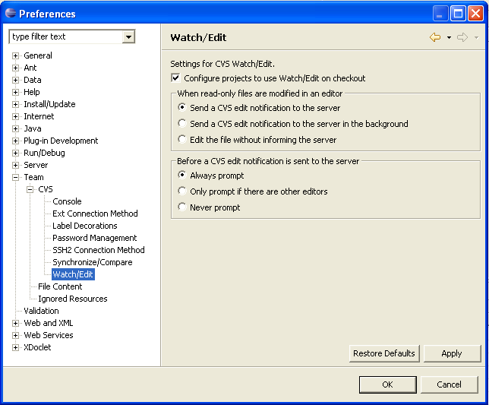
Figure 1
- Go to your project’s properties as shown in Figure 2 below.
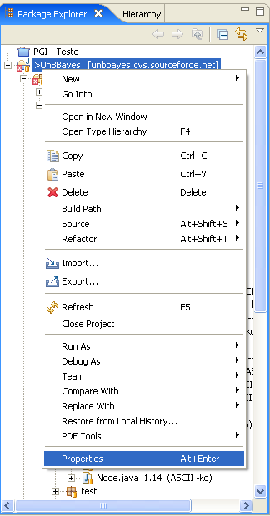
Figure 2
- Go to “CVS”.
- Configure CVS as shown in Figure 3 below.
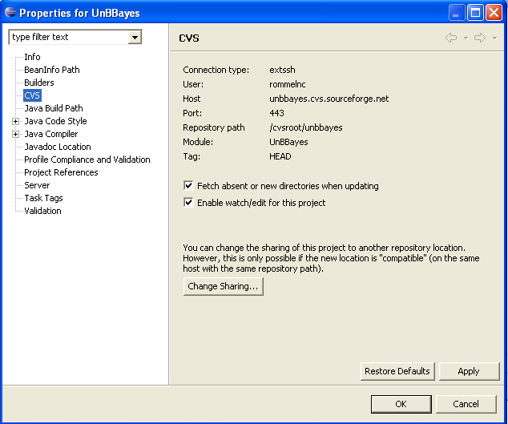
Figure 3
- To edit a file right click the file and go to “Team -> Edit” as shown in Figure 4 below.
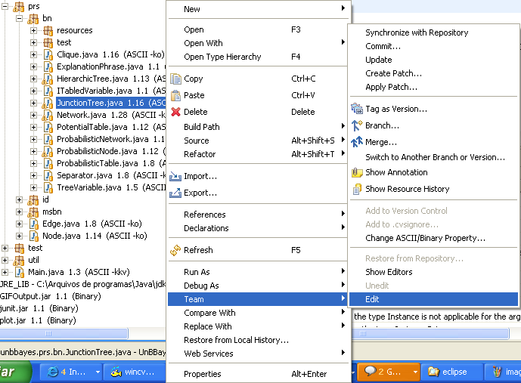
Figure 4
- You can also try to edit a file and the following box will be prompted for you to confirm file edition as shown in Figure 5 below.
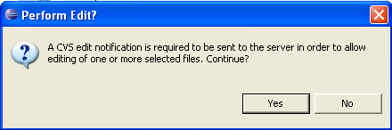
Figure 5
- The files being edited will be shown as in Figure 6 below.
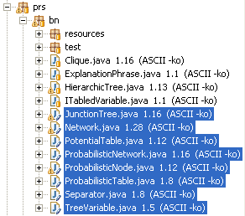
Figure 6
- Finally, to unedit a file right click the file(s) and go to “Team -> Unedit” as shown in Figure 7 below.
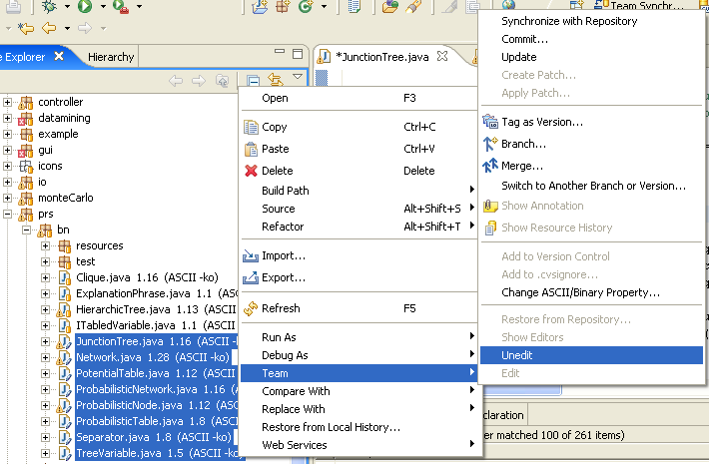
Figure 7

